

***INSTITUTE OF INFORMATION TECHNOLOGY***

***JAHANGIRNAGAR UNIVERSITY***

**Final Assignment**

**Course Tittle :** Data Structure

**Course Code :** ICT – 2101

**Submission Date :** 05/08/2021

**Submitted To Submitted By**

Dr. M. Abu Yousuf Md. Shakil Hossain

Professor Class Roll – 2023

IIT – JU Exam Roll – 192340

IIT – JU

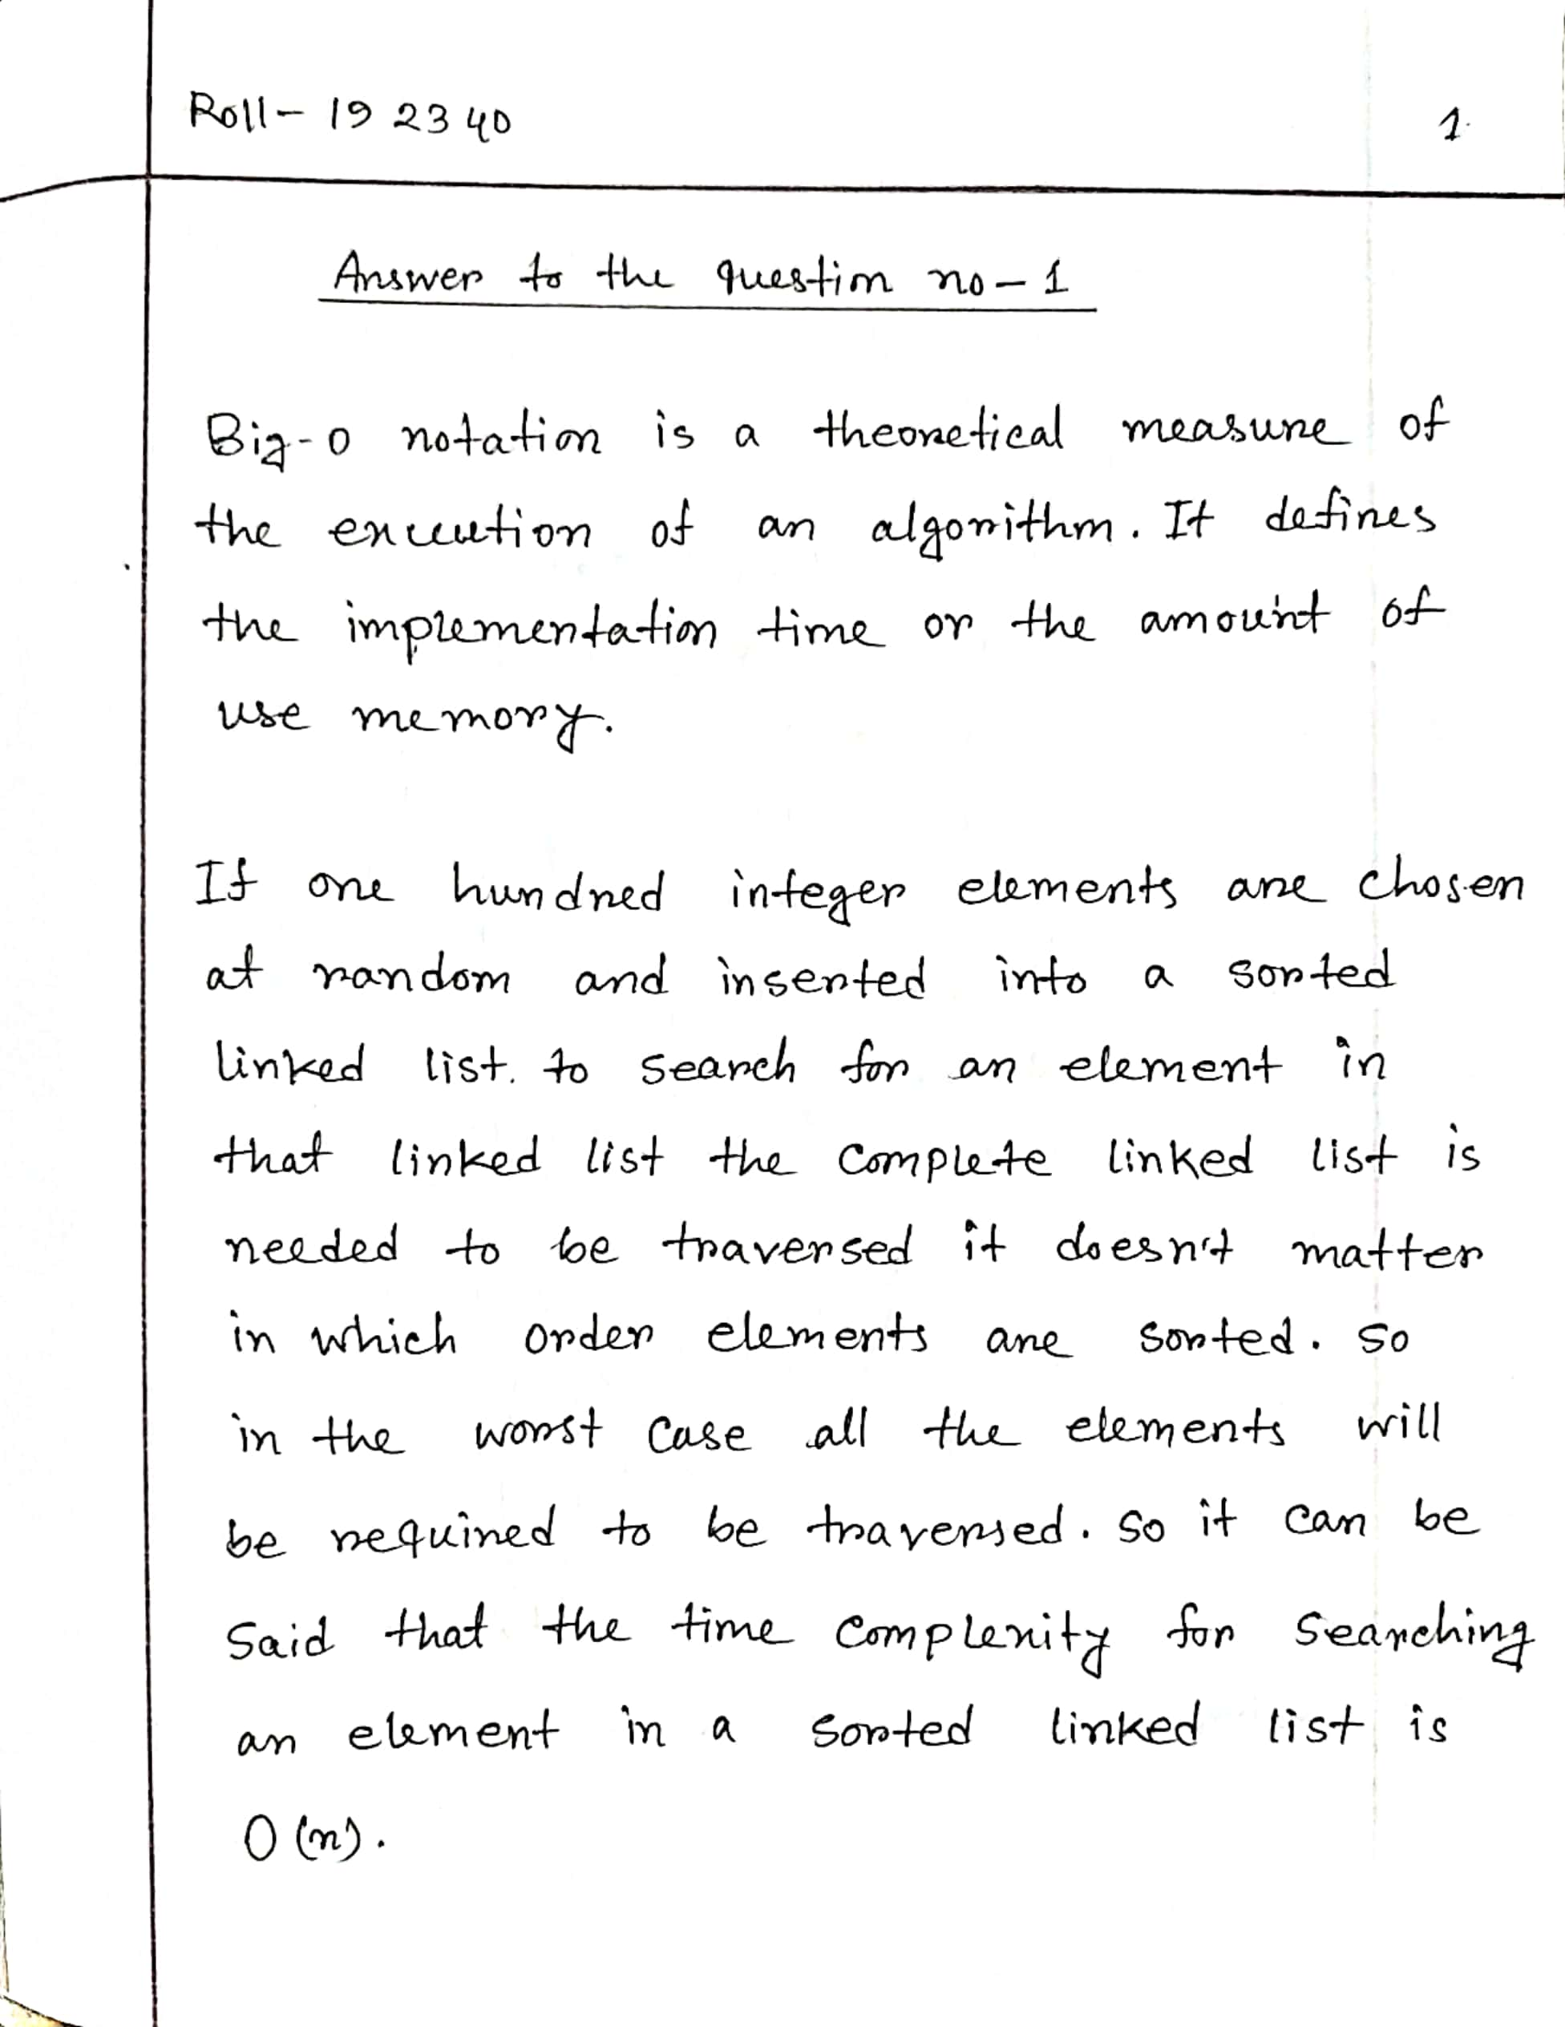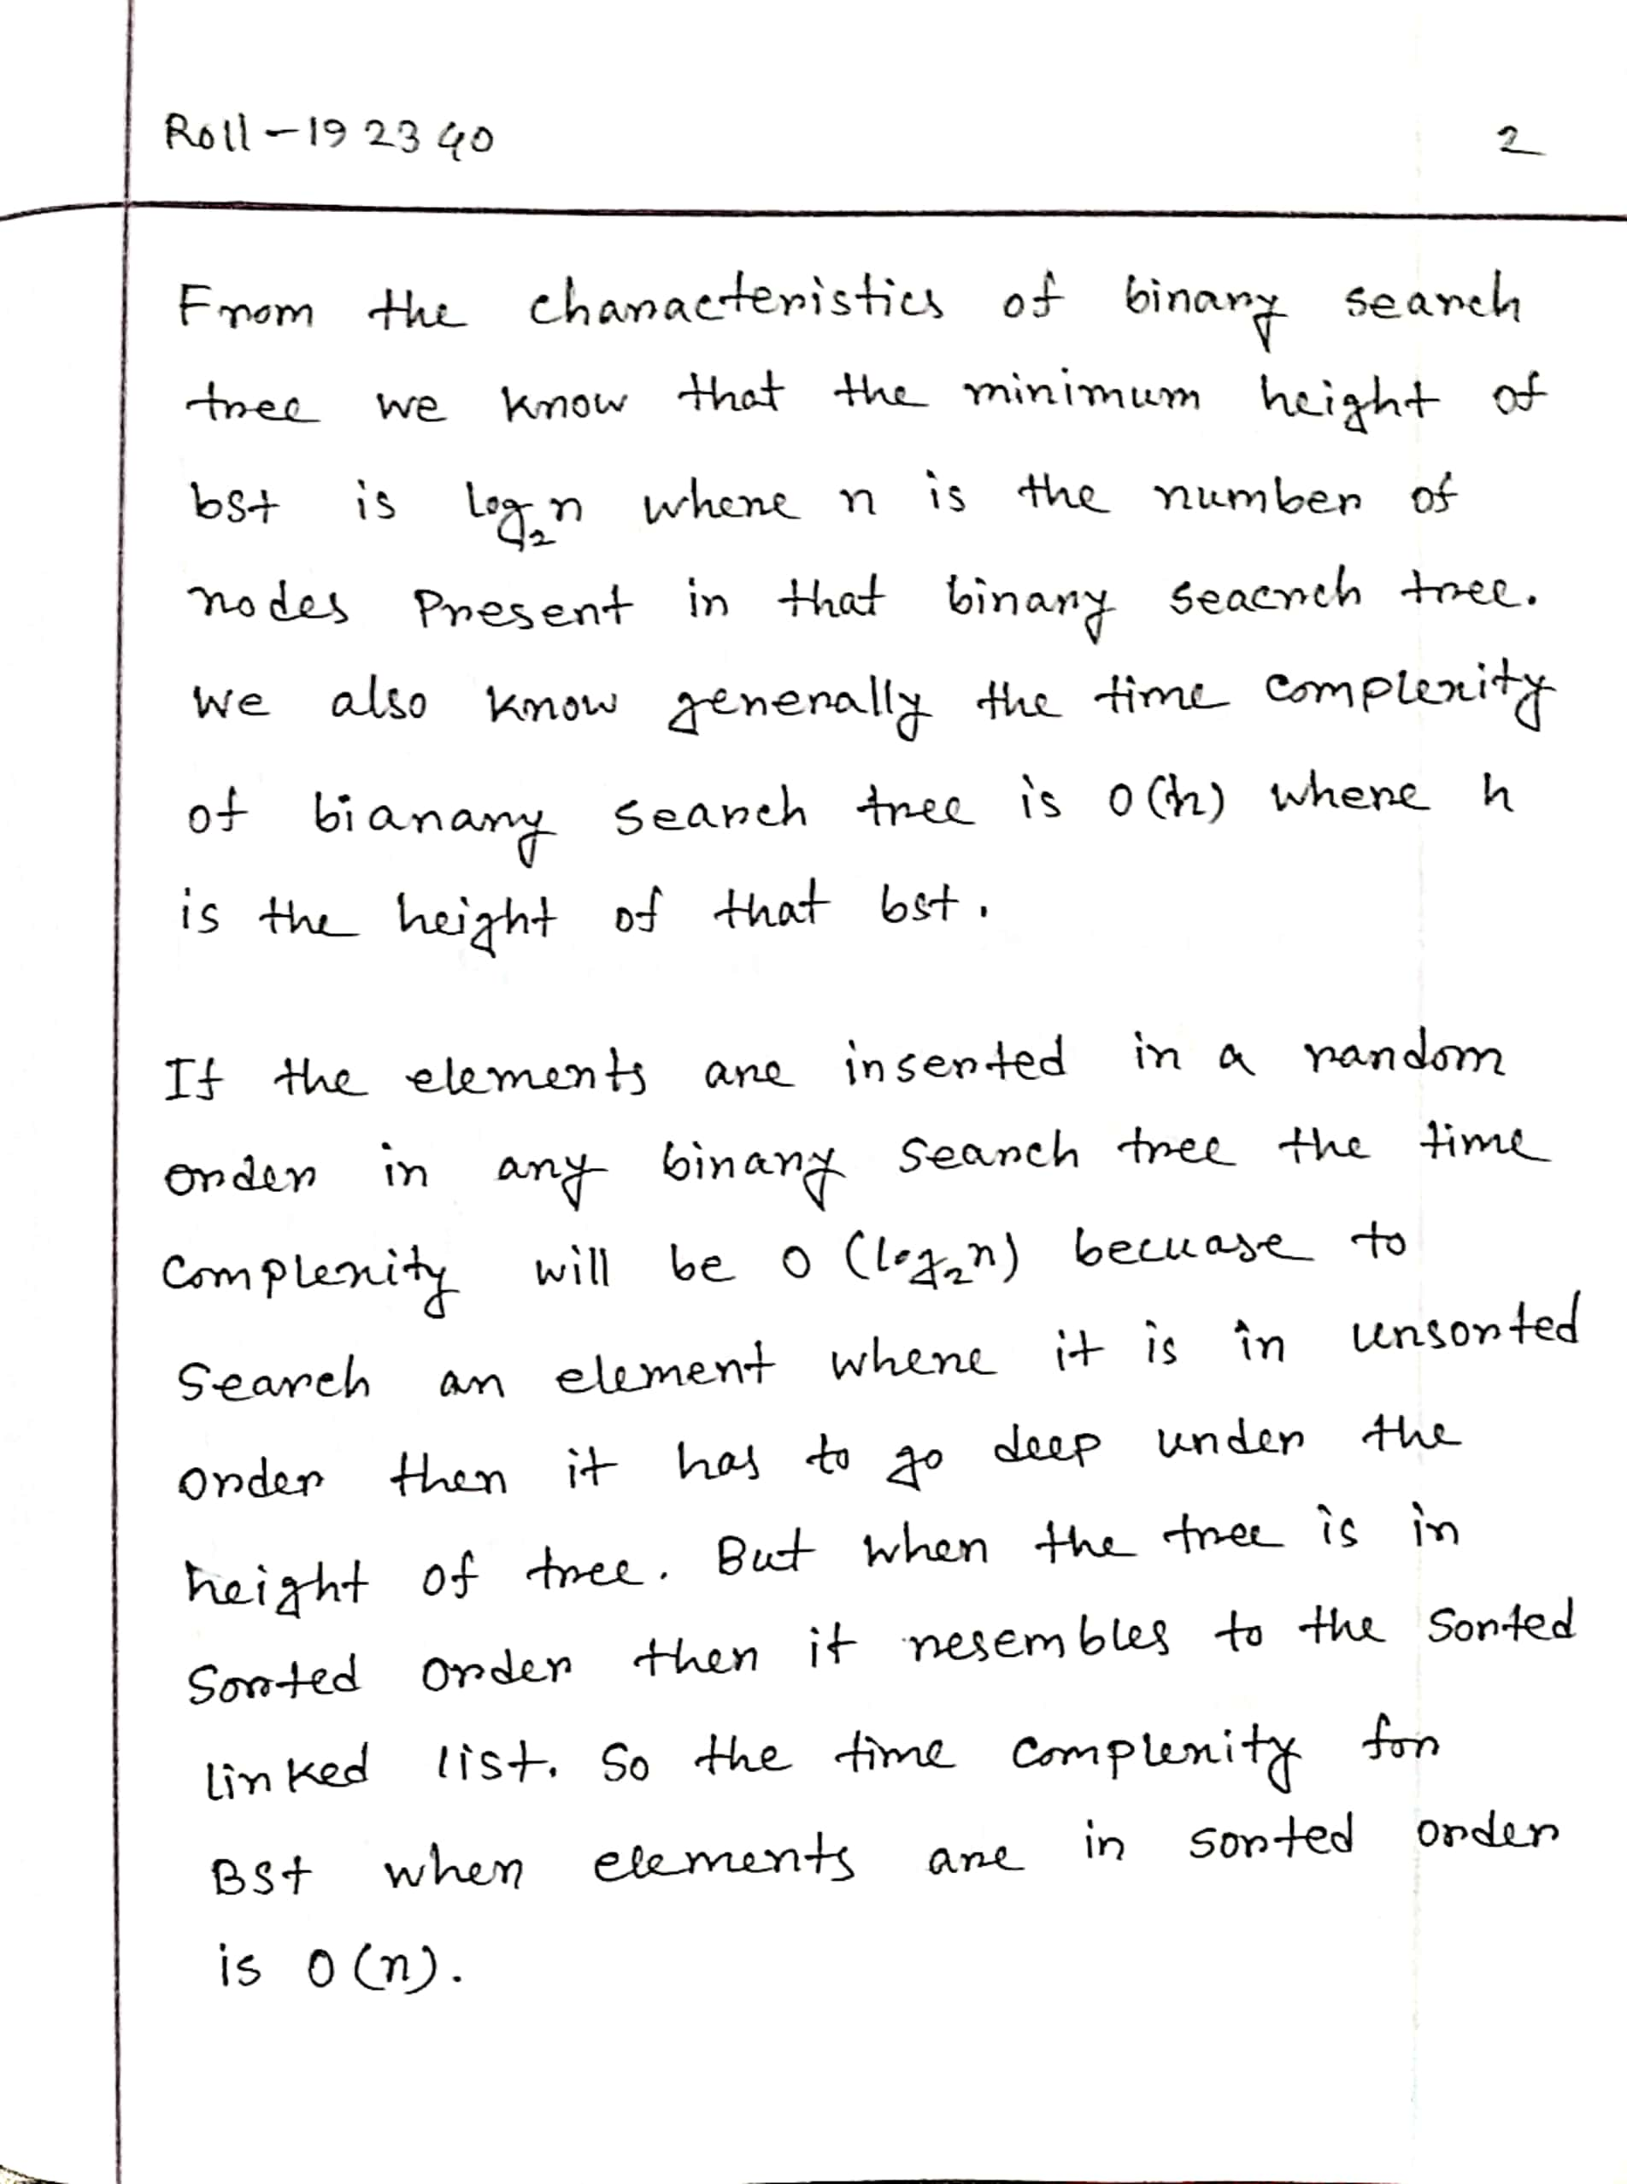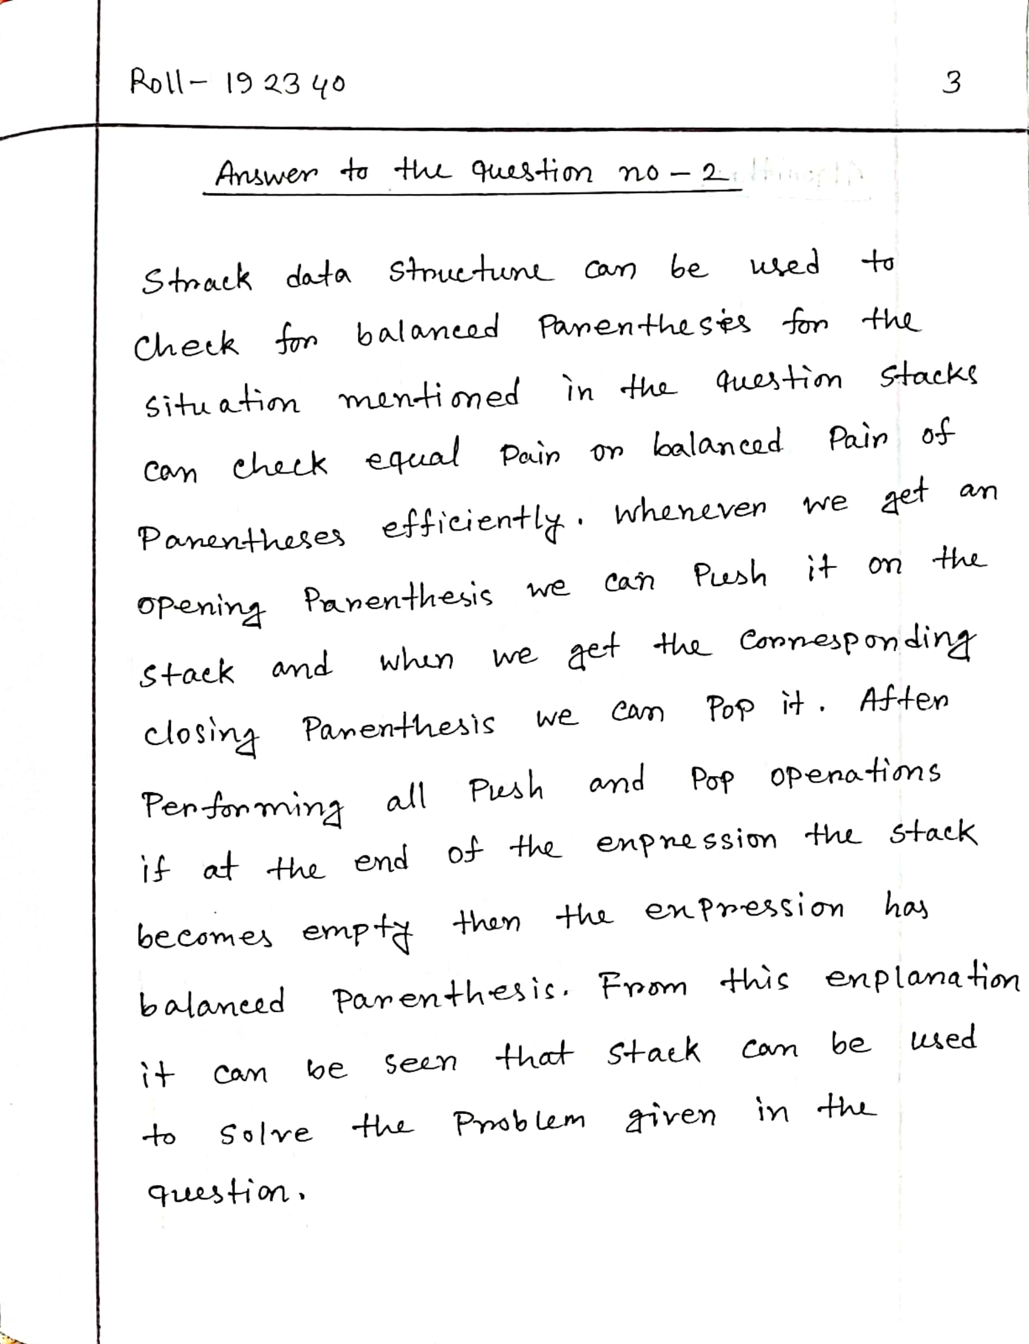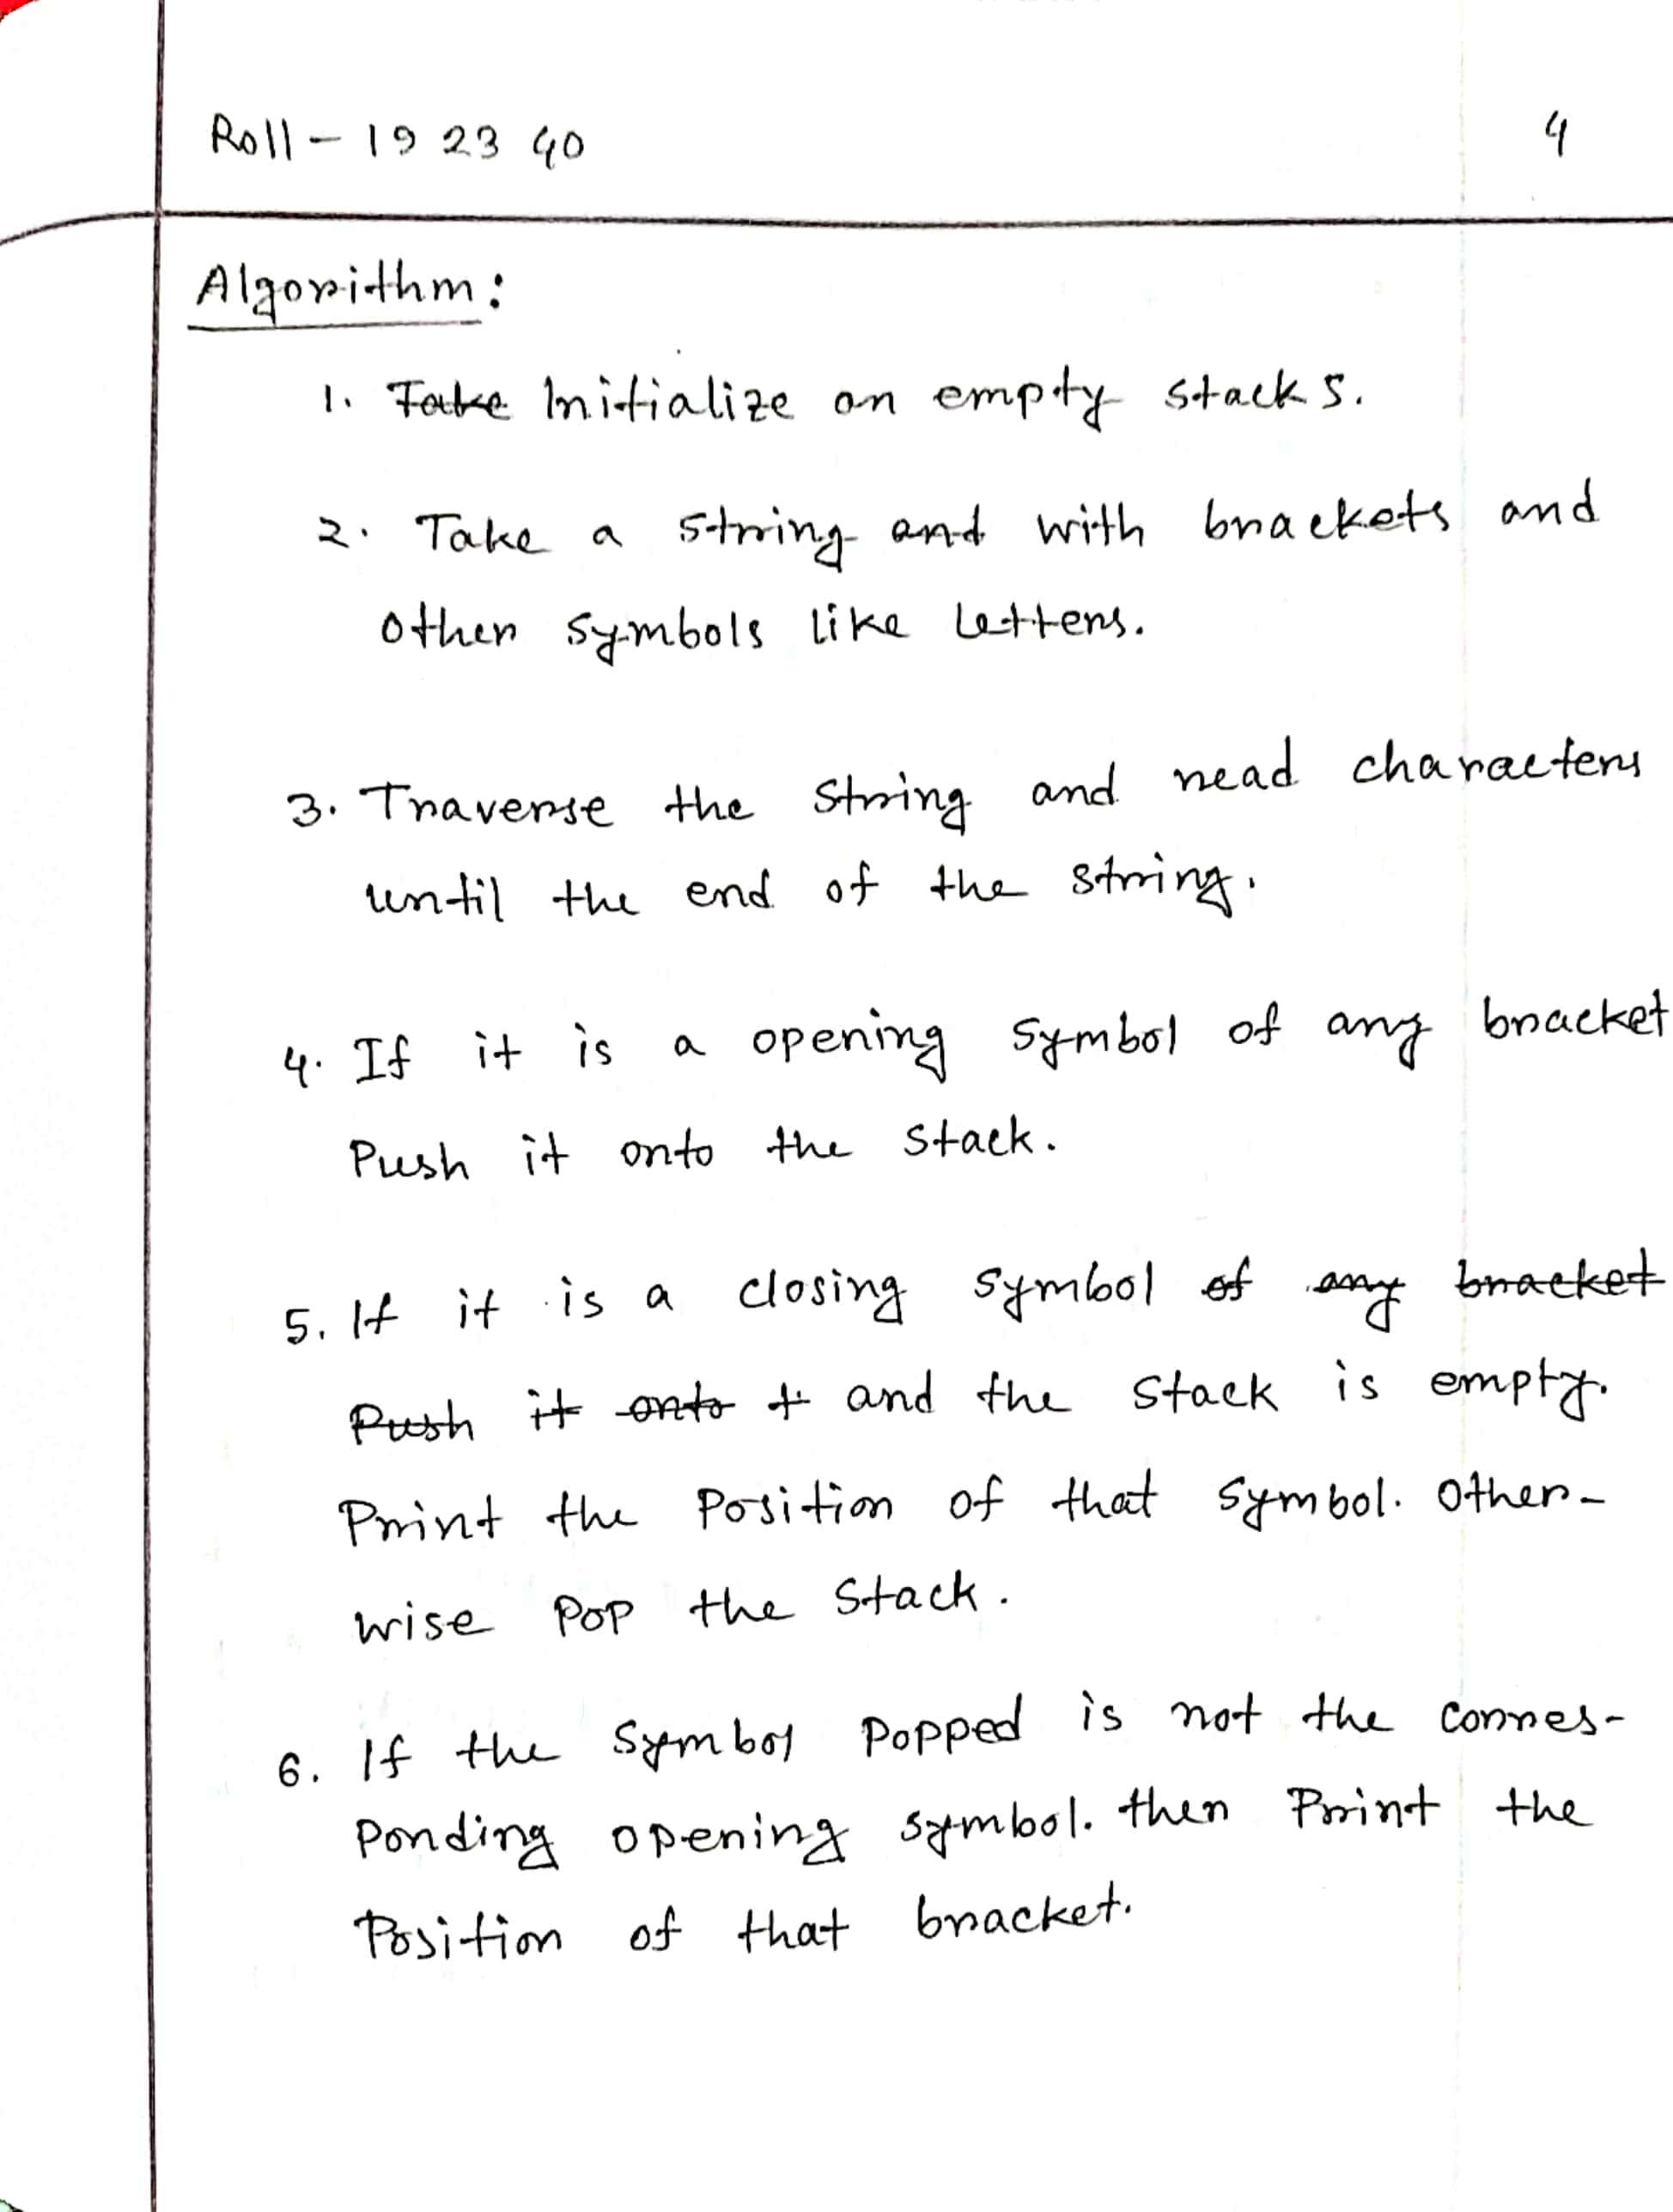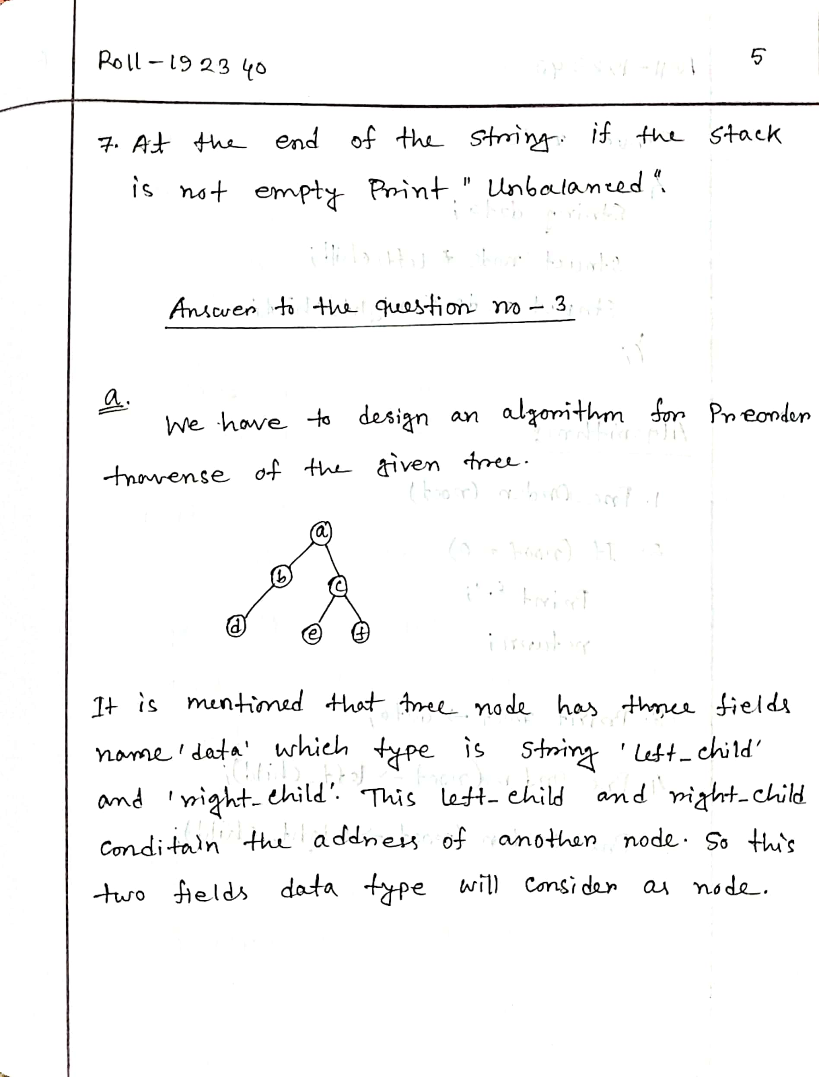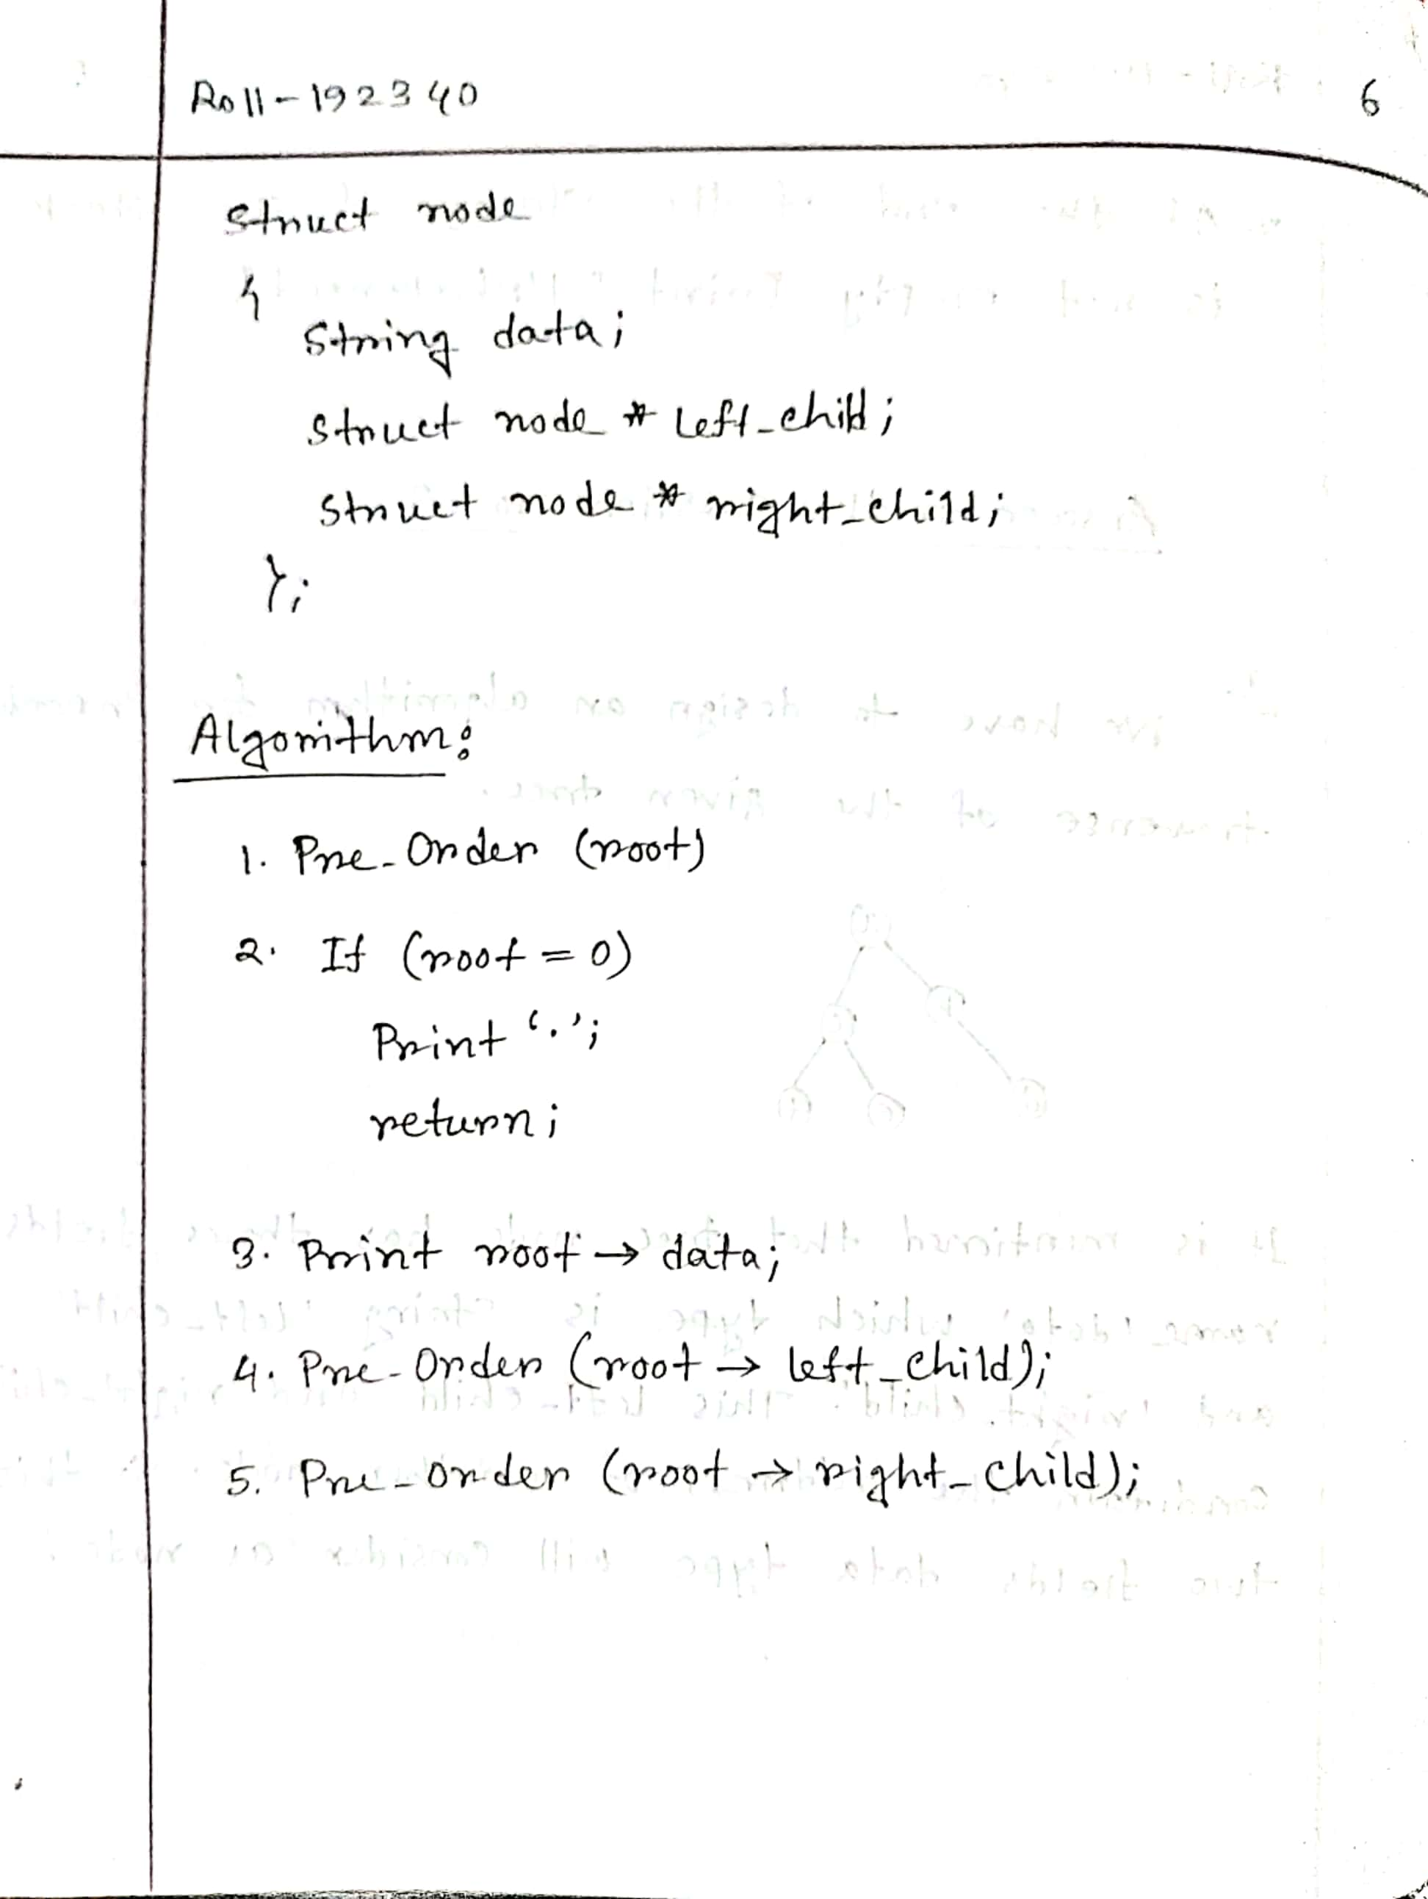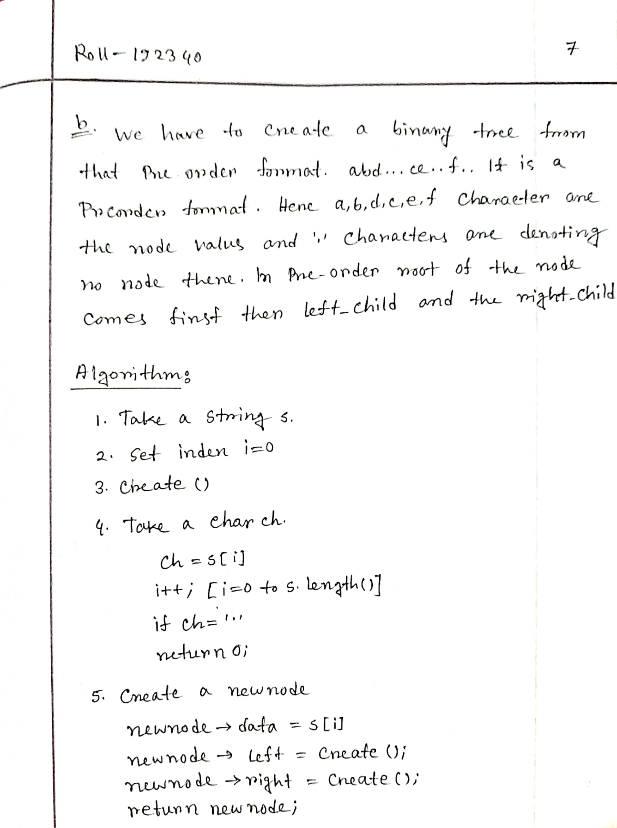

**THE END**